**Assignment Qns to be submitted by 15/03/2023**

1.Design an ER diagram for the following scenario:. There is a set of teams, each team has an ID (unique identifier), name, main stadium, and to which city this team belongs. Each team has many players, and each player belongs to one team. Each player has a number (unique identifier), name, DoB, start year, and shirt number that he uses. Teams play matches, in each match there is a host team and a guest team. The match takes place in the stadium of the host team. For each match we need to keep track of the following: The date on which the game is played The final result of the match. The players participated in the match. For each player, how many goals he scored, whether or not he took yellow card, and whether or not he took red card. During the match, one player may substitute another player. We want to capture this substitution and the time at which it took place. Each match has exactly three referees. For each referee we have an ID (unique identifier), name, DoB, years of experience. One referee is the main referee and the other two are assistant referee.

2. UPS prides itself on having up-to-date information on the processing and current location of each  
shipped item. To do this, UPS relies on a company-wide information system. Shipped items are  
the heart of the UPS product tracking information system. Shipped items can be characterized  
by item number (unique), weight, dimensions, insurance amount, destination, and final delivery  
date. Shipped items are received into the UPS system at a single retail center. Retail centers are  
characterized by their type, uniqueID, and address. Shipped items make their way to their  
destination via one or more standard UPS transportation events (i.e., flights, truck deliveries).  
These transportation events are characterized by a unique scheduleNumber, a type (e.g, flight,  
truck), and a deliveryRoute.  
Please create an Entity Relationship diagram that captures this information about the UPS  
system. Be certain to indicate identifiers and cardinality constraint.

3. Production tracking is important in many manufacturing environments (e.g., the pharmaceuticals  
industry, children’s toys, etc.). The following ER diagram captures important information in the  
tracking of production. Specifically, the ER diagram captures relationships between production  
lots (or batches), individual production units, and raw materials.

4. Convert the following ER diagrams to Min -Max notation

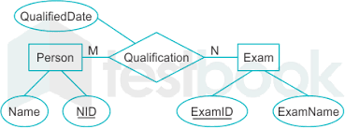

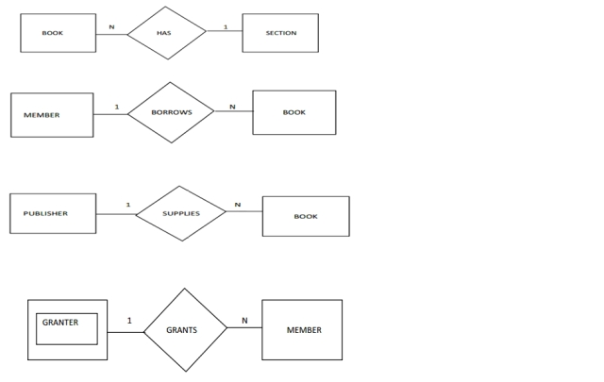

5. Draw and Write the architecture of DBMS in detail (Client server/ three tier architecture)